

***Aptech Computer Education***

*(Gulshan-e-Iqbal Campus)*

**A**

**PROJECT REPORT**

**ON**

**AURA WATCH**

**Submitted By:**

Munazza Kashif

**Guided By:**

Sir Ghufran Ahsan

|  |  |  |
| --- | --- | --- |
| **Sno** | **Topics** | **Page no** |
| **01** | **Acknowledgements** |  |
| **02** | **Synopsis** |  |

**Contents:**

|  |  |  |
| --- | --- | --- |
| **Sno** | **Topics** |  |
|  |  | **3**  3 |
| **03** | **Analysis** | **3-4** |

|  |  |  |
| --- | --- | --- |
| **04** | **E-project Design** | 5 |
| **05** | **User’s Guide** | 6 |
| **06** | **Developer Guide** | 10-11 |
| **07** | **Source Code** | 11 |

E-PROJECT REPORT

ACKNOWLEDGEMENTS

Aura Watch is a young company based in Italy where it draws inspiration for its models.

Each watch is distinguished by the tipe of marbe used from which the creation of the entire product is born.

Our dial is the heart of our business and policy.

The materials used reflect Italian style and culture, based on history and art.

For this reason we consider our products unique and innovative.

SYNOPSIS

**T**he thirst for learning , upgrading technical skills and applying the concept in real life environment at a fast pace is what the industry demands from it professional today.However busy work shedule far-flung location , unavailibity of convanient time-slot pose major barriers when it comes to applying the concept into realism and bence the need to look out for alternatives means of implimentation in the form of laddered approach

The above truely pose as constrains espacially for our students too! With their busy shedule it is indeed difficult for our students to keep up with the genuine and constant need for integrated application which can be seen live speacially so in the field of it education where technology can change on the spur of a moment **Well technology does come to our rescue at such times!!**

keeping the above in mind and in tune with our constant endeavour to use technology in our trainning model we at aptech have thought of revolutionizing the way our students learn an impement the concept using tool themselves by providing a live and synchronous eproject learning environment!!

Analysis

The E-project for website arrived at 12 oct 2019 then my teacher **SIR GHUFRAN AHSAN** guide as the E-project for how to create this . we got the task to create a watches website known as different sites we started our project from !4th october.

First of all before making a website first we use the paper work for how the website look like than i saw lot of sports website for structure but i want to satisfied then finally i found a more watches website called http//worldwatches.com/ where i understand the whole structure of my websites.

First i collect all watches images as per the project recuirements searching from google then i edit all the photos from adobe photo shop cs6 after editing it now i wanted to get the detailed information about all the sports i found it on google as well. On october 15 first i made a homepage inside the homepage i made a navigation bar using bootstrap4 then i made coursel sliders after then apply a grid system telling about what type of organic category we have then a call to action button and finnally the footer of the website.Another day some for contact page i easily manage to make a contact us page following the project recuirements on october 19 i started to make all the organic categgory one by one everything was working fine but i forgot to make a gallery information section and other stuff and i have having a probwhere to put the gallery option so i ask my teacher have gave me an idea then this prob was solved my website was almost completed the last thing for my website was the about us page then i easily find it on google and thats how my website got completed october25

**E-project Design**

Project design is an early phase of the project where a project key features, structures, criteria for success, and major deliverable are all planned out . The point is to develop one or more designs which can be used to achieve the desired project goals.

My e-project Design includes.

* DATA FLOW DIAGRAM(DFD)
* FLOW CHART

**DATA FLOW DIAGRAM(DFD)**

Administor

Web information/design

View web design

Update website informationon

Design website

Web Management

Web update

Web designing

Web

View about us

visit

Admin

contact

Contact web

deliver msg

Fills the form and send to admin

USER’S GUIDE

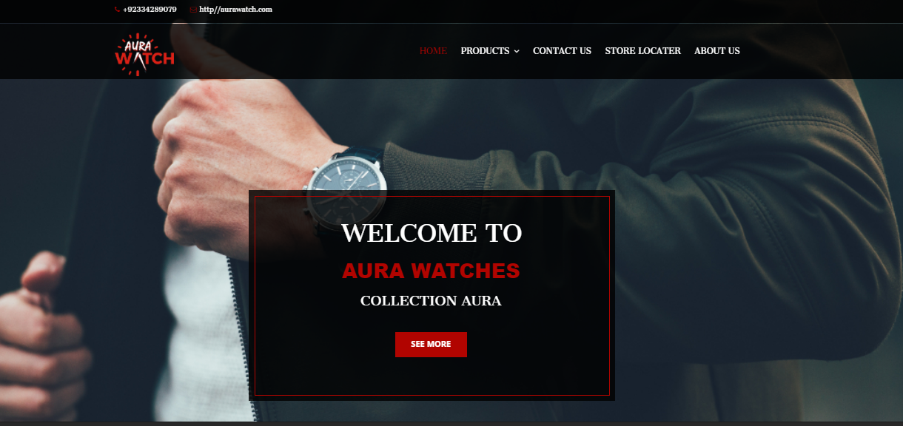

When you click on the home button tab it will appear the home screen . on the home screen first this is a banner which includes carousel indicaters as you can see the rounded shape if you click any of indicators it will shows up another the banner picture move down we have intro for our website

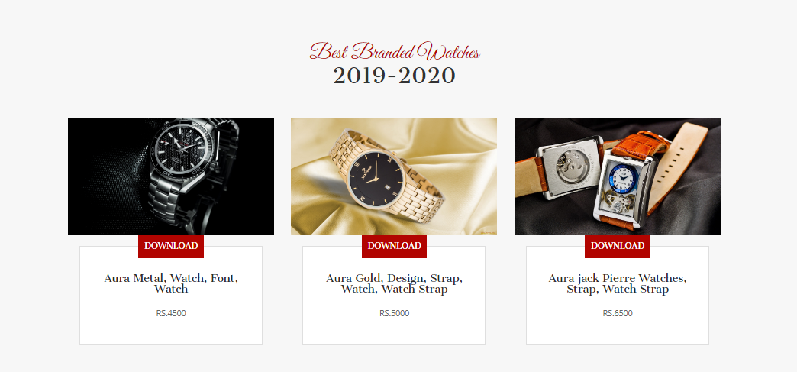

Product Details:

After click on product this is sub categaory of women and women watches

MAN WATCHES

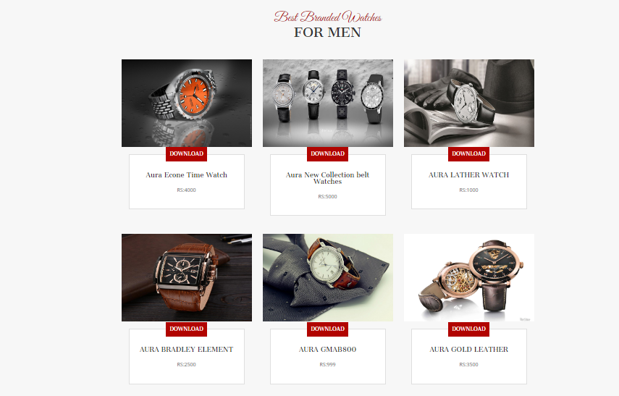

Women Watches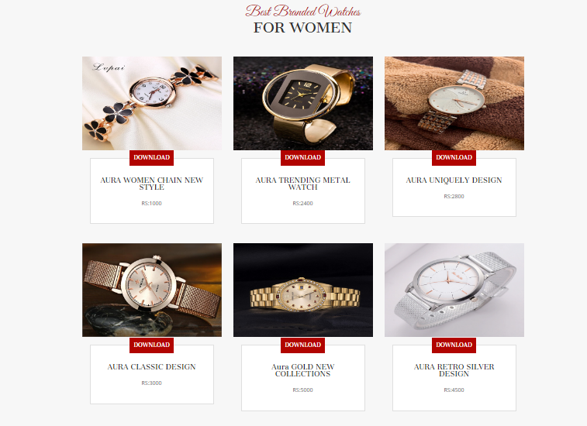

This is contact us section as you can see on this contact from it is also available company location email and address on this contact form you can type your name as well as your email adress and you can write your msg and send it to company

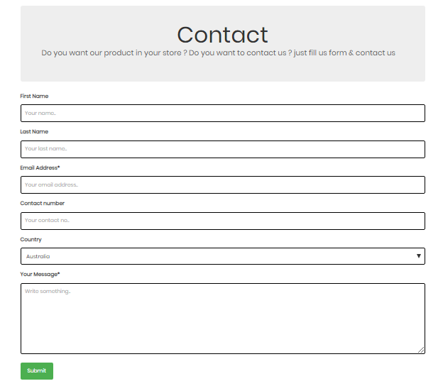

DEVELOPERS GUIDE

RESOURCES

Images

Images are located inside this folder dektop folder vision /imgs/Images

Aura Watches:This is logo image that is used image that is used inside the navigation bar

SOURCE CODE

Source code for this website is located insite the desktop folder vision all you have to do is open the following .html file when the website is open simple right click on view page source you will easily get the source code of thet html file just simple follow the same step for other .html file to gets its source code

Following are the html files:

1:Index.html

2:Contact.html

3:About.html

4:Product.html

Index.Html

In the index .html there are links for style css bootstrap 4 jquery and animate.css after this there is a bootstrap 4 navigation bar scroll down there is bootstrap 4 carousel indicaters then you will see grid system after this there is a CTA (call to action) button then there is a footer section and at the last you will see a script for java and jquery for animation.

Contact.Html

In the contact.html there are links for style css bootstrap 4 jquery and animate.css after this there is a bootstrap 4 navigation bar scroll down there is bootstrap 4 carousel indicaters then you will see grid system after this there is a CTA (call to action) button then there is a footer section and at the last you will see a script for java and jquery for animation.

About.Html

In the about.html there are links for style css bootstrap 4 jquery and animate.css after this there is a bootstrap 4 navigation bar scroll down there is bootstrap 4 carousel indicaters then you will see grid system after this there is a CTA (call to action) button then there is a footer section and at the last you will see a script for java and jquery for animation.

Product.Html

In the about.html there are links for style css bootstrap 4 jquery and animate.css after this there is a bootstrap 4 navigation bar scroll down there is bootstrap 4 carousel indicaters then you will see grid system after this there is a CTA (call to action) button then there is a footer section and at the last you will see a script for java and jquery for animation.

Source code:

Home

<!DOCTYPE html>

<html lang="en">

<head>

<meta charset="utf-8">

<meta http-equiv="X-UA-Compatible" content="IE=edge">

<meta name="viewport" content="width=device-width, initial-scale=1">

<link rel="icon" href="img/gt3.png" type="image/x-icon" />

<title>Aura Watches</title>

<link href="css/font-awesome.min.css" rel="stylesheet">

<link href="css/bootstrap.min.css" rel="stylesheet">

<link href="vendors/revolution/css/settings.css" rel="stylesheet">

<link href="vendors/bootatrap-date-time/bootstrap-datetimepicker.min.css" rel="stylesheet">

<link href="vendors/owl-carousel/assets/owl.carousel.css" rel="stylesheet">

<link href="css/style.css" rel="stylesheet">

<link href="css/responsive.css" rel="stylesheet">

</head>

<body style="overflow-x:hidden;">

<div id="preloader">

<div class="loader absolute-center">

<div class="loader__box"><b class="top"></b></div>

<div class="loader__box"><b class="top"></b></div>

<div class="loader__box"><b class="top"></b></div>

</div>

</div>

<!--================ Frist hader Area =================-->

<div class="first_header">

<div class="container">

<div class="row">

<div class="col-md-4">

<div class="header_contact_details">

<a href="#"><i class="fa fa-phone"></i>+92334289079</a>

<a href="#"><i class="fa fa-envelope-o"></i>http//aurawatch.com</a>

</div>

</div>

</div>

</div>

</div>

</div>

<!--================End Header Area =================-->

<!--================Navbar Area =================-->

<header class="main_menu_area">

<nav class="navbar navbar-default">

<div class="container">

<!-- Brand and toggle get grouped for better mobile display -->

<div class="navbar-header">

<button type="button" class="navbar-toggle collapsed" data-toggle="collapse" data-target="#bs-example-navbar-collapse-1" aria-expanded="false">

<span class="sr-only">Toggle navigation</span>

<span class="icon-bar"></span>

<span class="icon-bar"></span>

<span class="icon-bar"></span>

</button>

<a class="navbar-brand" href="index.html"><img src="img/GT3.png" ></a>

</div>

<!-- Collect the nav links, forms, and other content for toggling -->

<div class="collapse navbar-collapse" id="bs-example-navbar-collapse-1">

<ul class="nav navbar-nav navbar-right">

<li class="active"><a href="index.html">Home</a></li>

<li class="dropdown submenu">

<a href="#" class="dropdown-toggle" data-toggle="dropdown" role="button" aria-haspopup="true" aria-expanded="false">Products <i class="fa fa-angle-down" aria-hidden="true"></i></a>

<ul class="dropdown-menu">

<li><a href="mencollections.html">Men</a></li>

<li><a href="women.html">Women</a></li>

</ul>

</li>

<li><a href="Contact us.html">Contact Us</a></li>

</li>

<li><a href="location.html">Store locater</a></li>

</li>

</li>

<li class="dropdown submenu">

<a href="About Us.html">About Us</a>

</li>

</ul>

</div><!-- /.navbar-collapse -->

</div><!-- /.container-fluid -->

</nav>

</header>

<!--================End Navbar Area =================-->

<!--================Slider Area =================-->

<section class="slider_area">

<div class=slider_inner>

<div class="rev_slider fullwidthabanner" data-version="5.3.0.2" id="home-slider">

<ul>

<li data-slotamount="7" data-easein="Power4.easeInOut" data-easeout="Power4.easeInOut" data-masterspeed="600" data-rotate="0" data-saveperformance="off">

<!-- MAIN IMAGE -->

<img src="imgs/w1.jpg" alt="" data-bgposition="center center" data-bgfit="cover" data-bgrepeat="no-repeat" data-bgparallax="10" class="rev-slidebg" data-no-retina>

<!-- LAYERS -->

<!-- LAYER NR. 1 -->

<div class="slider_text_box">

<div class="tp-caption bg_box"

data-width="none"

data-height="none"

data-whitespace="nowrap"

data-x="center"

data-y="['350','350','300','250','0']"

data-fontsize="['55']"

data-lineheight="['60']"

data-transform_idle="o:1;"

data-transform_in="y:[-100%];z:0;rX:0deg;rY:0;rZ:0;sX:1;sY:1;skX:0;skY:0;s:1500;e:Power4.easeInOut;"

data-transform_out="y:[100%];s:1000;e:Power2.easeInOut;s:1000;e:Power2.easeInOut;"

data-mask_in="x:0px;y:0px;"

data-mask_out="x:inherit;y:inherit;"

data-start="2000"

data-splitin="none"

data-splitout="none"

data-responsive_offset="on">

</div>

<div class="tp-caption first_text"

data-x="center"

data-y="center"

data-voffset="['-20']"

data-Hoffset="['0']"

data-fontsize="['42','42','42','42','25']"

data-lineheight="['52','52','52','52','35']"

data-width="none"

data-height="none"

data-transform_idle="o:1;"

data-whitespace="nowrap"

data-transform_in="x:[105%];z:0;rX:45deg;rY:0deg;rZ:90deg;sX:1;sY:1;skX:0;skY:0;s:2000;e:Power4.easeInOut;"

data-transform_out="y:[100%];s:1000;e:Power2.easeInOut;s:1000;e:Power2.easeInOut;"

data-mask_in="x:0px;y:0px;s:inherit;e:inherit;"

data-mask_out="x:inherit;y:inherit;s:inherit;e:inherit;"

data-start="1000"

data-splitin="none"

data-splitout="none"

data-responsive_offset="on"

data-elementdelay="0.05" >WELCOME TO

</div>

<div class="tp-caption secand_text"

data-x="center"

data-y="center"

data-voffset="['45']"

data-Hoffset="['0']"

data-fontsize="['36']"

data-lineheight="['42']"

data-width="none"

data-height="none"

data-transform_idle="o:1;"

data-whitespace="nowrap"

data-transform_in="x:[105%];z:0;rX:45deg;rY:0deg;rZ:90deg;sX:1;sY:1;skX:0;skY:0;s:2000;e:Power4.easeInOut;"

data-transform_out="y:[100%];s:1000;e:Power2.easeInOut;s:1000;e:Power2.easeInOut;"

data-mask_in="x:0px;y:0px;s:inherit;e:inherit;"

data-mask_out="x:inherit;y:inherit;s:inherit;e:inherit;"

data-start="1000"

data-splitin="none"

data-splitout="none"

data-responsive_offset="on"

data-elementdelay="0.05" ><p style="font-family:'Arial Black', Gadget, sans-serif">AURA WATCHES</p>

</div>

<div class="tp-caption third_text"

data-x="center"

data-y="center"

data-voffset="['100']"

data-Hoffset="['0']"

data-fontsize="['24','24','24','24','16']"

data-lineheight="['34','34','34','34','26']"

data-width="none"

data-height="none"

data-transform_idle="o:1;"

data-whitespace="nowrap"

data-transform_in="y:[100%];z:0;rX:0deg;rY:0;rZ:0;sX:1;sY:1;skX:0;skY:0;opacity:0;s:2000;e:Power4.easeInOut;"

data-transform_out="y:[100%];s:1000;e:Power2.easeInOut;s:1000;e:Power2.easeInOut;"

data-mask_in="x:0px;y:[100%];s:inherit;e:inherit;"

data-mask_out="x:inherit;y:inherit;s:inherit;e:inherit;"

data-start="1200"

data-splitin="none"

data-splitout="none"

data-responsive_offset="on"

data-elementdelay="0.05" >NEW DESIGN COLLECTION

</div>

<div class="tp-caption btn_text"

data-x="center"

data-y="center"

data-voffset="['180']"

data-Hoffset="['0']"

data-fontsize="['16.75']"

data-lineheight="['26']"

data-width="none"

data-height="none"

data-transform_idle="o:1;"

data-whitespace="nowrap"

data-transform_in="y:[100%];z:0;rX:0deg;rY:0;rZ:0;sX:1;sY:1;skX:0;skY:0;opacity:0;s:2000;e:Power4.easeInOut;"

data-transform_out="y:[100%];s:1000;e:Power2.easeInOut;s:1000;e:Power2.easeInOut;"

data-mask_in="x:0px;y:[100%];s:inherit;e:inherit;"

data-mask_out="x:inherit;y:inherit;s:inherit;e:inherit;"

data-start="1200"

data-splitin="none"

data-splitout="none"

data-responsive_offset="on"

data-elementdelay="0.05" ><a class="submit_btn_bg" href="women.html">See More</a>

</div>

</div>

</li>

<li data-slotamount="7" data-easein="Power4.easeInOut" data-easeout="Power4.easeInOut" data-masterspeed="600" data-rotate="0" data-saveperformance="off">

<!-- MAIN IMAGE -->

<img src="imgs/w22.jpg"

alt="" data-bgposition="center center" data-bgfit="cover" data-bgrepeat="no-repeat" data-bgparallax="10" class="rev-slidebg" data-no-retina>

<!-- LAYERS -->

<!-- LAYER NR. 1 -->

<div class="slider_text_box">

<div class="tp-caption bg_box"

data-width="none"

data-height="none"

data-whitespace="nowrap"

data-x="center"

data-y="['350','350','300','250']"

data-fontsize="['55']"

data-lineheight="['60']"

data-transform_idle="o:1;"

data-transform_in="y:[-100%];z:0;rX:0deg;rY:0;rZ:0;sX:1;sY:1;skX:0;skY:0;s:1500;e:Power4.easeInOut;"

data-transform_out="y:[100%];s:1000;e:Power2.easeInOut;s:1000;e:Power2.easeInOut;"

data-mask_in="x:0px;y:0px;"

data-mask_out="x:inherit;y:inherit;"

data-start="2000"

data-splitin="none"

data-splitout="none"

data-responsive_offset="on">

</div>

<div class="tp-caption first_text"

data-x="center"

data-y="center"

data-voffset="['-20']"

data-Hoffset="['0']"

data-fontsize="['42','42','42','42','25']"

data-lineheight="['52','52','52','52','35']"

data-width="none"

data-height="none"

data-transform_idle="o:1;"

data-whitespace="nowrap"

data-transform_in="x:[105%];z:0;rX:45deg;rY:0deg;rZ:90deg;sX:1;sY:1;skX:0;skY:0;s:2000;e:Power4.easeInOut;"

data-transform_out="y:[100%];s:1000;e:Power2.easeInOut;s:1000;e:Power2.easeInOut;"

data-mask_in="x:0px;y:0px;s:inherit;e:inherit;"

data-mask_out="x:inherit;y:inherit;s:inherit;e:inherit;"

data-start="1000"

data-splitin="none"

data-splitout="none"

data-responsive_offset="on"

data-elementdelay="0.05" >WELCOME TO

</div>

<div class="tp-caption secand_text"

data-x="center"

data-y="center"

data-voffset="['45']"

data-Hoffset="['0']"

data-fontsize="['36']"

data-lineheight="['42']"

data-width="none"

data-height="none"

data-transform_idle="o:1;"

data-whitespace="nowrap"

data-transform_in="x:[105%];z:0;rX:45deg;rY:0deg;rZ:90deg;sX:1;sY:1;skX:0;skY:0;s:2000;e:Power4.easeInOut;"

data-transform_out="y:[100%];s:1000;e:Power2.easeInOut;s:1000;e:Power2.easeInOut;"

data-mask_in="x:0px;y:0px;s:inherit;e:inherit;"

data-mask_out="x:inherit;y:inherit;s:inherit;e:inherit;"

data-start="1000"

data-splitin="none"

data-splitout="none"

data-responsive_offset="on"

data-elementdelay="0.05" ><p style="font-family:'Arial Black', Gadget, sans-serif">AURA WATCHES</p>

</div>

<div class="tp-caption third_text"

data-x="center"

data-y="center"

data-voffset="['100']"

data-Hoffset="['0']"

data-fontsize="['24','24','24','24','16']"

data-lineheight="['34','34','34','34','26']"

data-width="none"

data-height="none"

data-transform_idle="o:1;"

data-whitespace="nowrap"

data-transform_in="y:[100%];z:0;rX:0deg;rY:0;rZ:0;sX:1;sY:1;skX:0;skY:0;opacity:0;s:2000;e:Power4.easeInOut;"

data-transform_out="y:[100%];s:1000;e:Power2.easeInOut;s:1000;e:Power2.easeInOut;"

data-mask_in="x:0px;y:[100%];s:inherit;e:inherit;"

data-mask_out="x:inherit;y:inherit;s:inherit;e:inherit;"

data-start="1200"

data-splitin="none"

data-splitout="none"

data-responsive_offset="on"

data-elementdelay="0.05" >COLLECTION AURA

</div>

<div class="tp-caption btn_text"

data-x="center"

data-y="center"

data-voffset="['180']"

data-Hoffset="['0']"

data-fontsize="['16.75']"

data-lineheight="['26']"

data-width="none"

data-height="none"

data-transform_idle="o:1;"

data-whitespace="nowrap"

data-transform_in="y:[100%];z:0;rX:0deg;rY:0;rZ:0;sX:1;sY:1;skX:0;skY:0;opacity:0;s:2000;e:Power4.easeInOut;"

data-transform_out="y:[100%];s:1000;e:Power2.easeInOut;s:1000;e:Power2.easeInOut;"

data-mask_in="x:0px;y:[100%];s:inherit;e:inherit;"

data-mask_out="x:inherit;y:inherit;s:inherit;e:inherit;"

data-start="1200"

data-splitin="none"

data-splitout="none"

data-responsive_offset="on"

data-elementdelay="0.05" ><a class="submit_btn_bg" href="mencollections.html">See More</a>

</div>

</div>

</li>

</ul>

</div><!-- END REVOLUTION SLIDER -->

</div>

</section>

<!--================End Slider Area =================-->

<!--================Service Area =================-->

<!--================Recent Blog Area =================-->

<section class="recent_bloger_area">

<div class="container">

<div class="s_black_title">

<h3>Best Branded Watches</h3>

<h2>2019-2020</h2>

</div>

<div class="row">

<div class="col-md-4">

<div class="recent_blog_item">

<div class="blog_img">

<img src="imgs/w2.jpg"alt="" >

</div>

<div class="recent_blog_text">

<div class="recent_blog_text_inner">

<h6><a href="AURA METAL.docx">Download</a></h6>

<a href="Poznan,poland.html"><h5>Aura Metal, Watch, Font, Watch

</h5></a>

<p>RS:4500</p>

</div>

</div>

</div>

</div>

<div class="col-md-4">

<div class="recent_blog_item">

<div class="blog_img">

<img src="imgs/w3.jpg" alt="">

</div>

<div class="recent_blog_text">

<div class="recent_blog_text_inner">

<h6><a href="Aura Gold Design Strap Watch.docx">Download</a></h6>

<a href="Dinant, Belgium.html"><h5>Aura Gold, Design, Strap, Watch, Watch Strap</h5></a>

<p>RS:5000</p>

</div>

</div>

</div>

</div>

<div class="col-md-4">

<div class="recent_blog_item">

<div class="blog_img">

<img src="imgs/w4.jpg" alt="">

</div>

<div class="recent_blog_text">

<div class="recent_blog_text_inner">

<h6><a href="Aura jack Pierre Watches.docx">Download</a></h6>

<a href="Aura jack Pierre Watches.docx"><h5> Aura jack Pierre Watches, Strap, Watch Strap </h5></a>

<p>RS:6500</p>

</div>

</div>

</div>

</div>

</div>

<br>

<br>

<br>

</div>

</section>

<!----Emerging Countries----->

<!--================End Recent Blog Area =================-->

<!--================End Recent Blog Area =================-->

<footer class="footer_area">

<div class="footer_widget_area">

<div class="container">

<div class="row">

<div class="col-md-4">

<aside class="f_widget about_widget">

<div class="f_w_title">

<h4 style="font-size:12px">ABOUT AURA WATCHES</h4>

</div>

<p>Aura Watch Official Website Italian Design Watch | Marble Details Shop now our watches and discover the new LeFons collection!#split# Bold Luxe Aura is the series of women's watches that empower your wrist with colour, brilliance and reliable Swiss craftsmanship. </p>

</aside>

</div>

<div class="col-md-4">

<aside class="f_widget contact_widget">

<div class="f_w_title">

<h4>CONTACT US</h4>

</div>

<p>Have questions, comments or just want to say hello:</p>

<ul>

<li><a href="#"><i class="fa fa-envelope"></i>http//aurawatch.com</a></li>

<li><a href="#"><i class="fa fa-phone"></i>+92 35291903</a></li>

<li><a href="#"><i class="fa fa-map-marker"></i>54 Street 5, F-8/3 F 8/3 F-8, Islamabad,

<br>Islamabad Capital Territory 44000, Pakistan</a></li>

</ul>

</aside>

</div>

<div class="col-md-4">

<aside class=" f_widget about_widget">

<div class="f_w_title">

<h4>Follow</h4>

</div>

<ul>

<li><a href="#"><i class="fa fa-facebook"></i></a></li>

<li><a href="#"><i class="fa fa-twitter"></i></a></li>

<li><a href="#"><i class="fa fa-google-plus"></i></a></li>

<li><a href="#"><i class="fa fa-linkedin"></i></a></li>

</ul>

</aside>

</div>

</div>

</div>

</div>

<div class="copy_right_area">

<div class="container">

<div class="pull-left">

<h5><p><!-- Link back to Colorlib can't be removed. Template is licensed under CC BY 3.0. -->

Copyright &copy;<script>document.write(new Date().getFullYear());</script>

<!-- Link back to Colorlib can't be removed. Template is licensed under CC BY 3.0. -->

</p></h5>

</div>

<div class="pull-right">

<ul class="nav navbar-nav navbar-right">

<li class="active"><a href="index.html">Home</a></li>

<li><a href="About Us.html">About Us</a></li>

<li><a href="Contact us.html">Contact Us</a></li>

</ul>

</div>

</div>

</div>

</footer>

<!--================End Recent Blog Area =================-->

<script src="js/jquery-2.1.4.min.js"></script>

<script src="js/bootstrap.min.js"></script>

<script src="vendors/revolution/js/jquery.themepunch.tools.min.js"></script>

<script src="vendors/revolution/js/jquery.themepunch.revolution.min.js"></script>

<script src="vendors/revolution/js/extensions/revolution.extension.slideanims.min.js"></script>

<script src="vendors/revolution/js/extensions/revolution.extension.layeranimation.min.js"></script>

<script src="vendors/revolution/js/extensions/revolution.extension.navigation.min.js"></script>

<script src="vendors/revolution/js/extensions/revolution.extension.parallax.min.js"></script>

<script src="vendors/bootatrap-date-time/bootstrap-datetimepicker.min.js"></script>

<script src="vendors/countdown/jquery.countdown.js"></script>

<script src="vendors/js-calender/zabuto_calendar.min.js"></script>

<script src="js/theme.js"></script>

</body>

</html>